Results
Broadband Access by Data Source
The violin and boxplots displayed in Figure 1 show the overall county distribution of broadband coverage according to FCC provider reports, Microsoft server logs, and ACS consumer-reports.
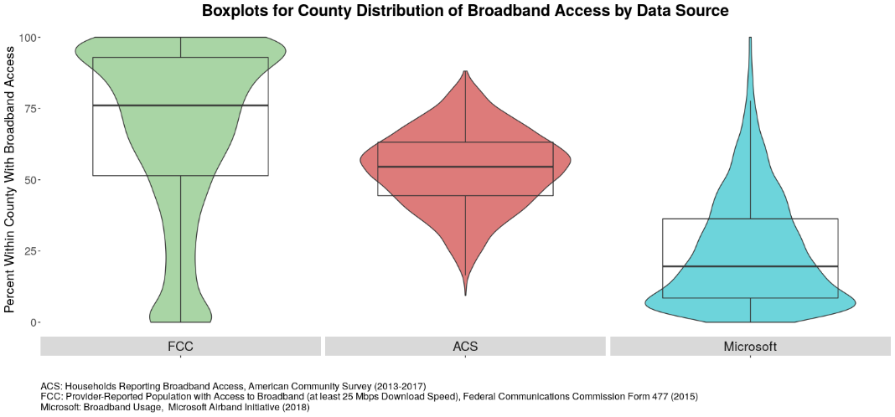
Figure 1: County distribution of broadband access by data source.
As shown in Figure 1, the FCC suggests an overall higher broadband coverage within counties compared to compared ACS and Microsoft data. FCC receives self-reported data on advertised coverage from providers, which potentially introduces error and a positive coverage bias if the reported advertised estimates do not match actual estimates. The FCC has other known data quality issues, including reporting entire block groups covered even if the whole block only has one subscriber or if the provider could provide access in the block within a typical service interval, which may lead to overestimates. Accordingly, the FCC claims that broadband is not available to 25 million Americans, whereas the Microsoft Airband Initiative—the data source which suggests the lowest broadband coverage—finds that around 163 million Americans do not use internet at 25 Mbps. Microsoft collected this data by analyzing their server logs when devices download Microsoft Office or related updates, and when the user accesses the Bing browser or other Microsoft products like Xbox consoles. Given that this sample likely excludes individuals who are not Windows users, it is possible that this data source is negatively biased in reporting broadband coverage. The ACS is a country-wide survey in which individuals report whether they have broadband access. ACS shows a coverage distribution between the FCC and Microsoft extremes, but similarly to Microsoft, it suggests that broadband coverage in the US is lower than the FCC reports.

Broadband Access by Data Source and Urbanicity
We further examined reported broadband coverage in the three data sources by urban status. Figure 2 visualizes broadband coverage reports by urbanicity, as determined by the RUCC codes.
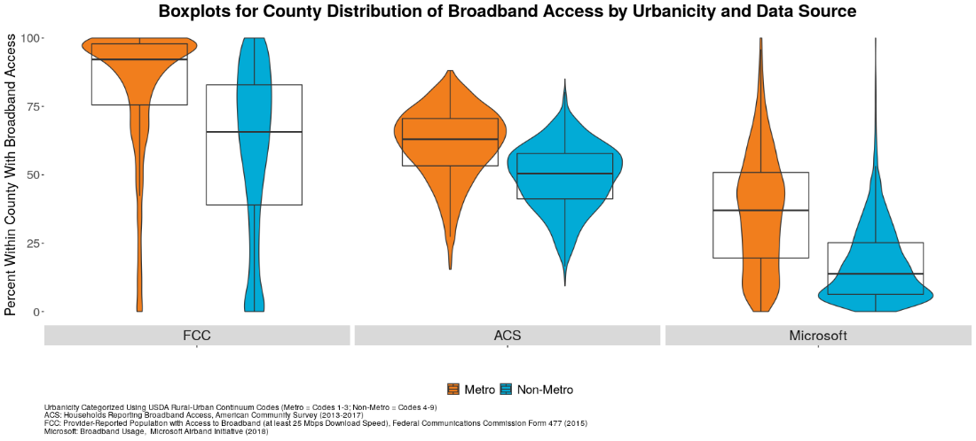 Figure 2: County distribution of broadband access by data source and urban status.
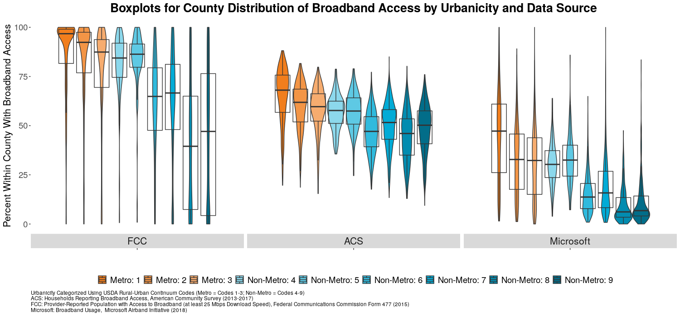 Figure 3: County distribution of broadband access by data source and RUCC code.

Both Figure 2 (using a dichotomized metro/nonmetro urbanicity variable) and Figure 3 (using full information RUCC code classification urbanicity variable) show that on average, metro areas have higher reported county broadband coverage compared to non-metro regions according to all three data sources. Thus, regardless of discrepancies in coverage levels that FCC, ACS, and Microsoft show, all three sources suggest that coverage is higher in urban versus rural areas. The distribution across RUCC codes in Figure 3 further illustrates the fact that more urban areas have higher reported broadband coverage. Another takeaway is that across all data sources, the most rural counties—counties with RUCC code 9—appear to have slightly higher coverage compared to those classified into the next highest rural level, RUCC code 8. All counties falling under these two codes are completely rural and have a population of less than 250,000 inhabitants. However, these results suggest that counties which are not adjacent to urban areas may have higher coverage compared to the rural counties that are closer to urban areas.
Data Source Discrepancies in Reported Broadband Access
We have previously explored the discrepancy between the FCC and the ACS data for individual states in the dashboard. However, we try and understand the discrepancy measure across counties with different RUCC codes. Figure 4 below shows the discrepancy and absolute discrepancy by county. We notice some negative distributions indicating that the FCC reported availability measure for that county is lesser than the coverage reported by the ACS. We develop an absolute discrepancy measure to just understand coverage percentage difference across the sources. The figures below confirm that the discrepancy in measure of broadband availability is much
Figure 4: County distribution of discrepancy measure by Urbanicity

Interactive Dashboard Illustrating Data Source Discrepancies in Broadband Coverage
To illustrate our findings, we developed a RShiny dashboard available at http://bband.policy-analytics.net. The user can select a state of interest, choose a level of geography (block group, census tract or county level), and subset visualizations into urban and rural areas based on RUCC codes. Each visualization also overlays major cities in each state, with larger points denoting cities with larger populations. At each level of geography, the user can access all available data for that geography by hovering over a particular county, tract, or block group. Figure 4 is snippet from the dashboard, showing discrepancy percentages between FCC and ACS-reported broadband coverage for the state of Alabama.

Figure 5: Alabama FCC-ACS Broadband Coverage Discrepancy Map at Block Group Level.

With the dashboard, users can thus interactively explore discrepancies in FCC, ACS and Microsoft broadband coverage reports. For example, Figure 6 shows absolute differences in ACS-reported and FCC-reported broadband coverage in Utah at census tract level. Figure 7 focuses on rural sections of Montana, isolating the visualization to nonmetro areas only and helping the user understand the range of discrepancies that exist outside metro areas.

Figure 6: Discrepancies Between FCC and ACS-Reported Broadband Coverage in Utah at Census Tract Level.
Figure 7: Discrepancies Between FCC and ACS-Reported Broadband Coverage in rural Montana at Census Tract Level.

Next steps
- We intend to compare the authoritative FCC data source and alternate sources of broadband coverage data to develop heuristics for reliability.
- Explore the relationship between percent discrepancy and sociodemographic factors for counties by urbanicity.
- Use FCC, ACS, and Microsoft data to obtain model-based broadband access predictions based on sociodemographic information (e.g. urbanicity, unemployment).

